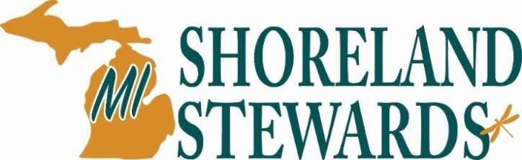
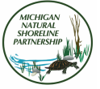

www.mishorelandstewards.org www.mishorelinepartnership.org

According to the National Lake Assessment the biggest threat to our nation’s inland lakes is the loss of lakeshore habitat. Results show that 40% of Michigan‘s inland lakes were rated as poor with another 20% rated as fair for loss of habitat and physical lakeshore complexity. These results indicate that high impact development activities such as clearing native vegetation for expansive lawns and large buildings, removing aquatic plants and installation of shoreline structures, such as seawalls are having a negative impact on Michigan inland lakes.
The Michigan Natural Shoreline Partnership (MNSP) is changing this trend through promotion and implementation of lake-friendly landscaping and erosion control methods. The MNSP has developed a new educational tool called the Michigan Shoreland Stewards Program.
For more information about the Michigan Natural Shoreline Partnership, visit the www.mishorelinepartnership.org or the Michigan Shoreland Stewardship Program, visit www.mishorelandstewards.org

The Michigan Shoreland Stewards Program is a voluntary web-based survey designed to:
- Provide recognition for shoreland property owners for using best management practices to protect their lake.
- Encourage property owners to use natural shoreland landscaping techniques.
- Provide educational resources to help property owners in managing their property for a healthy lake.
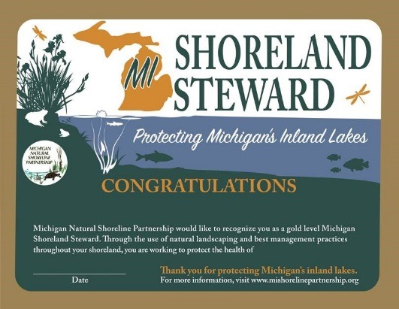
How Does the Survey Work?
The survey asks questions related to management practices in each of the four sections of a shoreland property: upland, buffer, shoreline and lake. Responses to the questions are rated to determine the shoreland steward recognition level.

What’s Your Level?
A gold, silver, bronze or starter level rating can be achieved. The survey program provides a certificate of recognition for the first three levels. Stewards then have the option to purchase a sign.
For more information on the MSS program contact:
Eli Baker Julia Kirkwood
AmeriCorps Member MNSP Chair
Tip of the Mitt Watershed Council MDEQ-Water Resources Division
eli@watershedcouncil.org KIRKWOODJ@michigan.gov

Gold Level Certificate
The website will go live at the end of April 2016!

